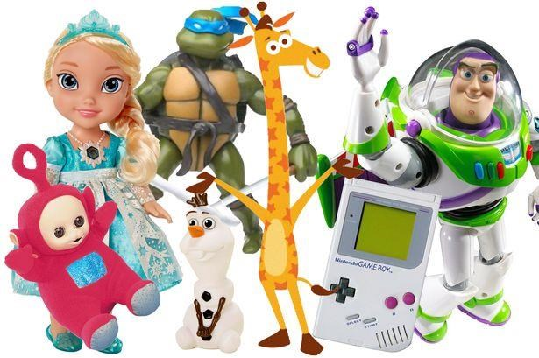

Enable Ireland’s

National Assistive Technology
Training Service

Accessible Apps, Games and
Toys

Welcome to
Enable Ireland’s National Assistive Technology Training Service
Accessible Apps, Games and Toys booklet. We have gathered together information
on a range of accessible toys. It includes a variety of accessible games, apps and
toys.

National Assistive Technology Training Service,

Enable Ireland,

Sandymount Avenue,
Sandymount,

Dublin 4.

Tel: 01 2184100

or

visi
t

ou
r

contac
t

pag
e

Contents
Contents 2
Introduction 3
Apps for Tablets 3
Computer Games 10
Game Consoles (Xbox and Wii) 18
Switch adapted toys 19
Visual toys 21
Auditory 24
Tactile toys 26
Musical toys and instruments 28
Electronic Toys 31
Traditional Games 33
Irish businesses 34
Useful links 39
Appendix 40

Introduction

Leisure and gaming can be sometimes overlooked when considering the needs of an individual. But it can be an important part of a young person’s development and help enable inclusion into society. For children the benefits of play have been shown to build up imagination, promote social skills, advance physical development and develop problem solving skills etc. Here we look how we can make leisure time and gaming more inclusive to a wide range of abilities. There are now many options for accessible toys, game consoles and switch adapted toys.
The information has been prepared by Enable Ireland’s National Assistive Technology Service. The toys shown are not necessarily recommendations but simply a selection of items which may be of interest, particularly at times such as Christmas and birthdays, when presents are high on the list of priorities.

Apps for Tablets

Apps
Nowadays tablets are now an option for accessible toys or games as there are a wide range of apps some specifically designed for special needs. Accessibility settings now built into the operating systems of iOS and android now make them more accessible. Accessibility features include tools for low vision, blind users or users with motor control issues. See this YouTube video for further information.
https://youtu.be/mjshKQOtGSI (iOS) https://youtu.be/m36ZUPGBElo (Android)

Below is just a sample of some apps for the iPad specifically designed for special needs. Many are available for both the iOS app store and the Android play store. See further list in the appendix.

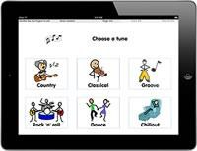
ChooseIt! Maker 3
The ChooseIt! Maker 3 App allows you to view your cause and effect activities, literacy activities, sound lotto and matching activities, multiple choice activities, games, and quizzes. It includes three sample activities which demonstrate some of the many ways CM3 can be used to create a variety of learning activities using symbols, pictures and sounds.
https://itunes.apple.com/gb/app/chooseit!-maker-3/id682571868 https://play.google.com/store/apps/details?id=air.com.inclusive.cm3

Hurdle Champion
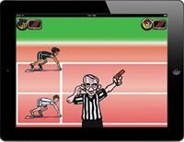
Choose a character and take part in a hurdle race against the computer. Works with a single switch or by touching the screen. This game provides a motivating way to develop switch and timing skills.
Choose from three levels of difficulty to give you a chance to improve your performance. A clear visual clue is shown to tell you when it is time to help your runner clear the hurdles by pressing a switch or touching the screen.
https://itunes.apple.com/gb/app/hurdle-champion/id557894486

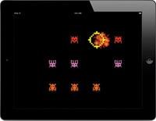
Space Shooter
Stop the alien invasion with your space shooter – a real blast from the past. Features to help children with special needs, this game can be played with a tap anywhere on the screen or by using a single external switch to zap the aliens.
https://itunes.apple.com/gb/app/space-shooter/id557890309
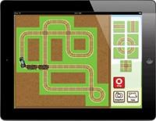

Train Tracker
Train Tracker wherever you go! Touch and switch accessible, uses one or two switch scanning. Compatible with all currently available iPad switch interfaces. Build your track and set your train on its way.
https://itunes.apple.com/gb/app/train-tracker/id530126114

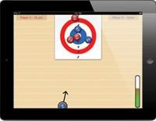
New Age Kurling
An accessible kurling game for two players, choose the direction and speed of your kurl by simply touching the screen or pressing an external switch. A game to help develop switch timing, hand eye coordination and strategy skills. Use your four kurls to go for a high score or to knock your opponent off the target.
https://itunes.apple.com/gb/app/new-agehttps://itunes.apple.com/gb/app/new-age-kurling/id530447888kurling/id530447888

Further apps
HelpKidzLearn have created motivational Apps specifically for children and designed to meet a range of special educational needs including switch access for those with physical disabilities. http://www.helpkidzlearn.com/apps

iOS

Switch options
Switch access is built right into the accessibility options, providing alternative access to these tablet devices.
Further information: http://www.janefarrall.com/how-do-i-use-a-switch-with-an-ipad-ios-7-overview/ Switch access demonstration videos http://www.youtube.com/watch?v=TH540kuBDwo#t=5 http://www.youtube.com/watch?v=1OyUI1yH_O0#t=0

New Accessibility in iOS version 10
The latest operating systems iOS10 for the iPad/iPhone/iPod touch, has introduced some changes to the accessibility options of these devices which include Display Accommodations. This is a new section in the Accessibility Settings that brings together a few existing display options (Invert Colors, Grayscale, Reduce White Point) with a couple of new ones (Color Tint and options for three different types of color-blindness).
Also the text to speech options in iOS 10 (Speak Selection and Speak Screen) will now provide sentence by sentence highlighting. A new Typing Feedback setting can help you if you find you are often entering the wrong text. You can choose to hear the last character or word you typed (or both). The entire Speech system also can take advantage of some additional high quality voices: Allison, Ava, Fred, Susan, Tom and Victoria for U.S. English. A new Pronunciation Editor can now get VoiceOver to get a little bit closer to the correct pronunciation for unusual names or words.
Touch Accommodations accessibility feature on your iOS device to change the way your device's screen responds to touch. You can set your device to respond to touches only after holding your finger on the screen for a certain period of time, called the hold duration. Or to start using Ignore Repeat or Tap Assistance with Use initial or final Touch Location https://youtu.be/U3vNtjCxpcY

Android
Switch access is also available in the version of Android Lollipop version 5 and above. This feature is design for people with limited access to the touch screen. Using externally connected switches a user can navigate around the home screen of the tablet, open apps, and navigate between clickable objects on the screen. Within the accessibility settings you can choose for example options to use a single switch with auto scanning or two switches with step scanning. There are also new features to improve the contrast of text and options to assist people who are colour blind.
A number of blue tooth switches and keyboards that can be used such as the Blue2 switch from AbleNet. Keys or switches can be assigned to actions such as start auto scan, click, long click, home, back etc. To get switch access started you need to first pair a Bluetooth switch or keyboard and also enable Switch Access under accessibility.
A useful guide for setting up your new Android tablet is available from
AbleNet.

For Hands-free access for Android see http://www.atandme.com/?cat=150

Switch Interfaces
Below is a sample of few switch interfaces of which there are several. Some work either iOS or Android devices or both.

NEW Blue2™ Switch
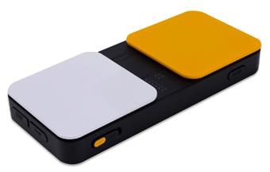
The NEW Blue2 Bluetooth switch provides single or dual switch access to iDevices running iOS 7, OS X Mavericks, and all switch accessible apps or software on OS X, Windows, and Android. The Blue2 connects to your device via a Bluetooth connection.

http://www.ablenetinc.com/Assistivehttp://www.ablenetinc.com/Assistive-Technology/Switches/Blue2-Bluetooth-SwitchTechnology/Switches/Blue2-Bluetooth-Switch
$179.00

APPlicator for iPad
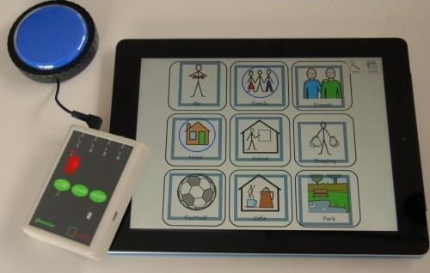
This APPlicator Switch Interface provides switch access to your iPad. The switch interface can provide access to both (switch accessible) Apps and Music in your device. Various features to cater for a wide range of requirements. Works with iPads, iPods and iPhones.
£140 http://www.inclusive.co.uk/switch4apps-p5978

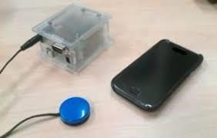
Tecla Shield
Tecla gives access to iPhone, iPad, iPod Touch and Android devices to individuals who find it difficult to use a touch-screen.€349 http://gettecla.com/

Toys for iPads

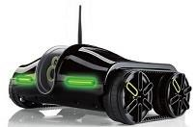
Rover 2.0 Spy Tank
The Rover works over Wi-Fi rather than Bluetooth. It has built-in night vision imaging so you can see in the dark, and it streams video. The app also lets you adjust the camera angle, listen to audio, and turn headlights on or off The downside to this one is that it'll only work where you have Wi-Fi signal.
https://www.amazon.com/Rover-2-0-App-Controlled-Wireless-Tank/dp/B0093285XK

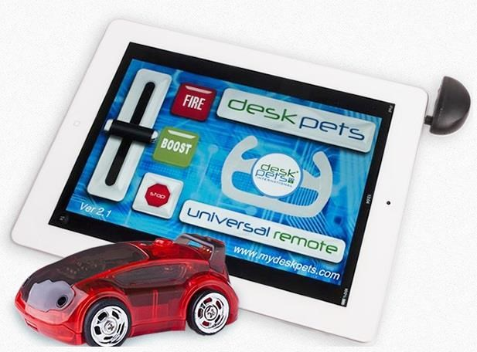
Deskpets
Desk Pets are a range of micro robotic toys. They are available as: AppBots which are app controlled toys using either an Android or Apple device or RCBots which are remote controlled toys. These included a handheld remote controller.
They both can charge via a USB charging system. 40 minutes of charge, which will give you about 25 minutes of play? Desk Pets range is from 6 – 10 feet. http://www.mydeskpets.com/ http://www.youtube.com/watch?v=zkFAKCfHTp4

More options
An online shop with app related toys http://www.imore.com/coolest-remote-controlled-toys-your-iphone-and-ipad
Apptivity™ creates a new play experience for the toys by turning tablets into moving digital worlds! http://play.mattel.com/mobile-apps Apptivity Case review https://youtu.be/2FTqjI7Gq8M
iPhone Accessories: http://www.apple.com/shop/iphone/iphone-accessories/toyshttp://www.apple.com/shop/iphone/iphone-accessories/toys-games?page=1games?page=1

iPad accessories

Big Grips
Big Grips are made from a soft, squishy foam where the iPad fits into the frame. Protection against drops and cushion to hold the device. A matching stand is also available. Comes in eight colours
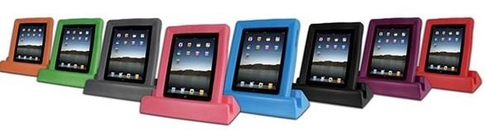
http://www.inclusive.co.uk/big-grips-bundles-p5773
£37

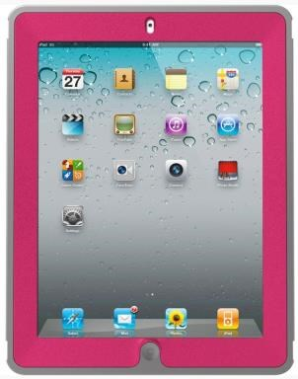
Otterbox covers
Otterbox offers a variety of cases for portable devices. They provide greater protection against drops, and bumps. Some cases also have built-in screen protectors. Price ranges in various models.
http://www.otterbox.com/apple-ipad-cases/apple-ipadhttp://www.otterbox.com/apple-ipad-cases/apple-ipad-cases,default,sc.htmlcases,default,sc.html

Mounting the iPad
Mounting your tablet on a suitable mount can make it become easier to see and access, especially for individuals with mobility difficulties.
Below, is just a sample of the many options that are now available for mounting your tablet.

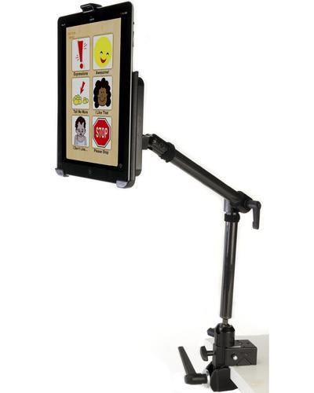
Hover Mounting System
This is a light, sturdy mount with a Super Clamp base. Can mount to a table or circular bar. There are three separate locking joints that can be adjusted.
http://www.inclusive.co.uk/hover-mounting-system-for-iPad-p6562
£200

Flexzi 3 for iPad Air 2
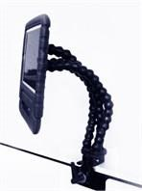
Flexzi 3 is an strong, triple-stranded Flexzi, complete with detachable iPad case. Available with a clamp base or a desktop standing base.
http://www.inclusive.co.uk/flexzi-3-ipad-air-2

Mount'n Mover
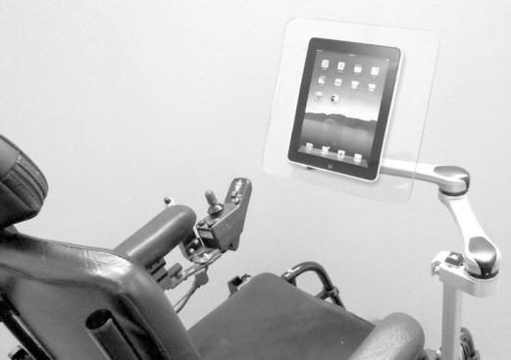
This mount can be attached to a wheelchair. Levers on the mount allow the user to independently move and tilt the device to different positions. €1000 http://www.mountnmover.com/ https://youtu.be/sOkOYQsUR6A

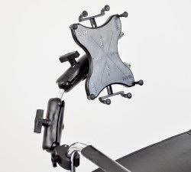
Ram Mounts wheelchair tablet mount
Ram Mounts have a range of mounting components to mount various portable devices. One of there products is a universal 10" tablet holder for wheelchairs. This mount can only be mounted to a circular bar. Visit the link below for more information:
Video: https://www.youtube.com/watch?v=j8hZajHdl9w
More information http://goo.gl/qA5NLI

Further Resources

Useful tips/links in educational settings. http://www.spectronicsinoz.com/blog/apple/ http://www.spectronicsinoz.com/apps-for-special-education http://www.spectronicsinoz.com/apps-for-literacy-support http://www.spectronicsinoz.com/iphoneipad-apps-for-aac

Computer Games
There are a wide range of games available for the general PC. Games that require a high skill level in hand/eye coordination may not be accessible for many users. However some mainstream games can be made more accessible with additional hardware or software as seen below in alternative input methods. Fortunately also there are many games that have been designed to be more accessible to play such as one switch games. There are a number of resources dedicated to accessible games that provide discussion forums and game reviews.
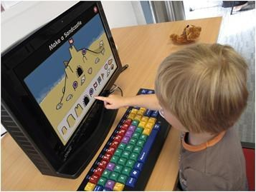

Alternative input methods
Before considering specialize software to access a computer, it’s worth looking at alternative methods to access your computer. The standard method or input device to control a computer is your standard keyboard and mouse. If this is not suitable for the user, then there are a range of other options that emulate the keyboard and mouse.

Alternative mice and keyboards
If the standard computer mouse and keyboard is unsuitable for the user there are many alternatives to the standards options as can be seen in the following videos.
o http://www.youtube.com/watch?v=dfAGRcoxVWg&feature=plcp o http://www.youtube.com/watch?v=GH_Jmza_qWs&feature=plcp

Touch screens

Touch screens: touch screens are fast becoming the norm in terms of mobile devices and computers. They can be used as an alternative option for mouse control. Additionally using an onscreen keyboard will allow text entry. Touch screens are available in a range of sized and can replace the standard computer screen on a desktop PC. They are available from most computer stores.
https://www.elotouch.com/touchscreen-monitors.html

Switch access programs
This type of software can enable switch control of the keyboard and mouse. Customised grids can be made to suit the user and application. Switches are used to activate a scan and select cells within the grid.
- e.g. “Grid2”,
http://www.smartboxat.com/software/the-grid-2/ o Communicator http://www.tobiidynavox.com/communicator5/
- “Switch Access to Windows”, http://acecentre.org.uk/special-accesshttp://acecentre.org.uk/special-access-to-windowsto-windows

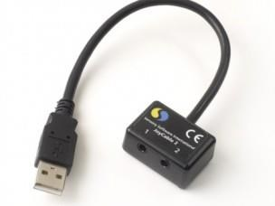
Switch interface for PC
The JoyCable is an easy way to plug switches into a computer. The JoyCable plugs into the USB port and you can connect one or two switches, with standard (3.5mm) switch inputs. The JoyCable work with popular software such as The Grid 2, Clicker or Widgit software. Using the switch driver you can assign keystrokes or mouse emulation to the connected switches.
https://thinksmartbox.com/product/joycable/

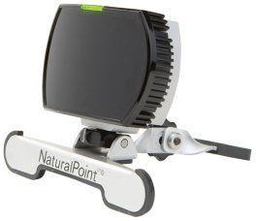
Headmouse options
A headmouse device tracks a user’s head position in order to control the mouse. SmartNav is a headmouse device that sits on top of the computer screen
https://thinksmartbox.com/product/smartnav-pro/

Enable Viacam is a free headmouse option and uses the computer’s webcam for tracking.
https://openassistive.github.io/OATSoft/2016/06/21/EnableViacam/

Text to Speech programs
Text to speech will speak out text on the computer screen. There are a number of options below for text to speech software.
NaturalReader is a free TTS program that allows you to read aloud any text. The free version of the software converts Microsoft Word files, webpages, PDF files, and emails into spoken words.
Text2Speech is a free program that converts text into audible speech. You can play the text at a custom rate and volume, have the text be highlighted as it’s read, and export the text into a WAV or an MP3 file.
Balabolka is a TTS program that allows you to read clipboard content and text from several types of files, such as DOC, EPUB, HTML, MOBI, LIT, CHM, PRC, PDF, and RTF files.
Claroread and Texthelp are both commercial products that provide text to speech and much more.
o http://www.clarosoftware.com/index.php?cPath=355 o http://www.texthelp.com/UK/our-products/readwrite

Voice Control
The VAC system is a program which you use to issue commands to your game or any program. Use your voice to speak words or phrases to issue commands to your game.
http://www.dwvac.com/index.html https://youtu.be/ts7mInfR4t0

For regular dictation of text, Dragon Naturally Speaking works well http://www.nuance.com/dragon/index.htm?ref=discoverlist

Eyegaze
There are various eye gaze systems available that track a user’s eye position in order to control the mouse pointer. Common suppliers include Tobii Technology, Alea Technologies and EyeTech Digital Systems.
https://youtu.be/p4KXAMKvy1E

One switch games
- Oneswitch.org.uk: This website offers information on accessible gaming and hosts a download section with many one-switch games. http://www.oneswitch.org.uk/2/switch-downloads.htm
- Marblesoft produces accessible games http://www.marblesoft.com/cart/index.php?route=product/category&pat h=26_31
- RJ Cooper has a selection of free games http://rjcooper.com/rj's-freehttp://rjcooper.com/rj's-free-games/index.htmlgames/index.html
- Eelke Folmer’s projects http://eelke.com/projects/navigating-avatar-singleswitch.html

Example of One switch game
Strange Attractors was created for a "One-Switch" competition.
Just because the only button used by the game is the space bar (and Esc to exit) doesn't mean the game play isn't complex and unique.

Pressing the spacebar activates the gravity drive of your craft and creates an attractive force between yourself and the other objects in the game. Your goal is to sling and bounce yourself from the bottom of the level through the portal at the top. http://ominousdev.com/

Mainstream games
Sadly, a lot of games do rely on speed of input, especially first person shooters such as Call of Duty and the Battlefield series. However, some Roll Play Games are suitable for a wider range of gamers as they are less reliant on input speed as some other games. Here is a sample of old and new, that might be suitable.

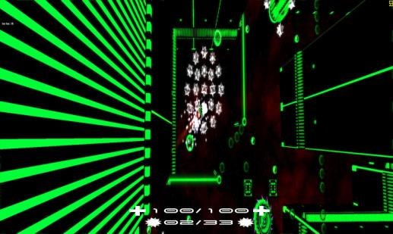
No Man’s Sky
This is a new title, on release it got very bad press as it was perceived to have left out promised features and generally did not live up to the hype surrounding it. However, the company that makes it has recently released a patch with a load of bug fixes and the first in what they say is a long line of new content for the game. The game is a space-based exploration and resource gathering game. There can be some combat (which is where input speed is important), but that’s not the focus of the game as a whole. It looks interesting, and the focus on exploration and gathering over combat means there’s a lot do that won’t require fast or accurate input, so those unable to react to situations quickly should still get as much out of the game as anyone else.
https://youtu.be/vpkXfzkmBVY

Minecraft
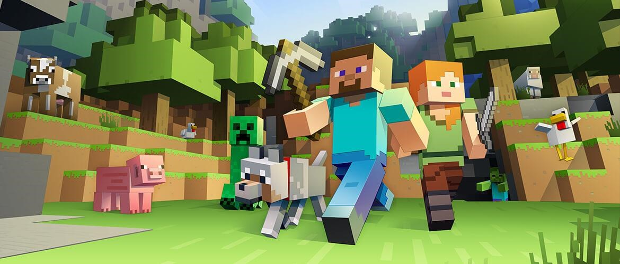
An old favorite of the internet. As above, its focus is more on exploration, resource gathering and building. It’s best described as a digital Lego box (and looks about the same). There’s no real requirement for input speed and accuracy is as much about placing blocks on each other so there’s no time pressure.
https://youtu.be/vnopybLY8zs?list=PLn7CSjAPE5FNWUlVGY-8ePeLuo9LGfj5o

Skyrim and Fallout 4
These are two RPG’s by Bethesda. They are both big, open world games that players can explore while on a series of quests given by various characters encountered in the game world. While there is a heavy focus on combat, it’s not as fast or as “twitch” based as other games such as the shooters. In terms of content, both feature a fair amount of blood splatter (Skyrim more than Fallout), mostly to be seen after fights as an effect in the environment but Skyrim especially does have a few areas where one can encounter already bloodied areas (usually associated with a quest). Skyrim was originally released about five years ago, but was re-released in October as Skyrim: Special Edition with updated graphics and lighting effects. Fallout 4 has been out about a year now.
https://youtu.be/cVrMhe3cXJg https://youtu.be/aDvtP3pvSjU

Hero’s of Might and Magic
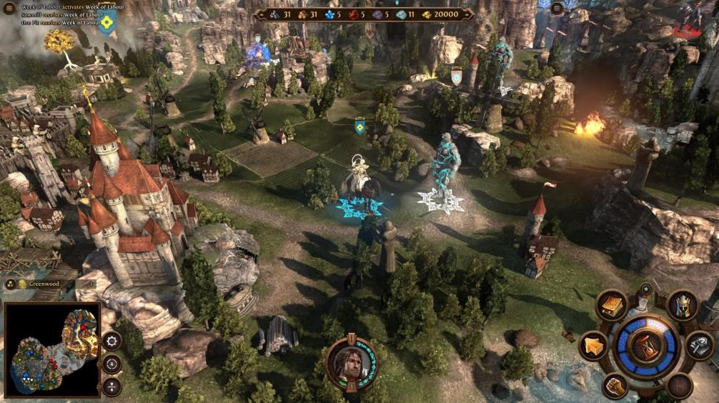
This is an old series of games on the PC. They’re unlikely to be available in shops, but the online service Steam should have them for sale. They’re turn based games, so a player effectively has an unlimited amount of time to make a move. Like Skyrim, they’re a fantasy RPG with quests and exploration, but rather than use a 1st or 3rd person perspective, you use travel points on a map to get from place to place. All combat is turn based, with players selecting creatures to fight and then the game’s AI running the combat. This removes any time pressure normally associated with combat in a game, meaning it should be quite accessible to everyone. https://youtu.be/emOu9EEzYPA

RTS games
Real Time Strategy games such as Star Craft may be worth considering. While they can get a little hectic at times, a lot of the gameplay relies on forward-planning and resource management. As such, input speed is less of a factor in gameplay. Planning and defense (which can quite often be automated) are more important in these games, and combat is always done by the AI. Player input is needed to assign targets, but after that, units can be left alone to perform their tasks. Most combat units will engage enemies automatically when encountered, so a player simply needs to send them to an area on the map rather than click a specific target (unless they want to).

Walking Simulators
This is a new genre of games that has sprung up over the past few years. It encapsulates a type of game that is generally 1st or 3rd person but contains no combat gameplay. The player is simply exploring a story through movement and interaction with the environment. Most famous are titles such as “Everyone’s gone to the Rapture”, “Dear Esther” and “The Stanley Parable”. Due to the lack of combat, there’s no pressure for input speed or accuracy. At points in the environment, players may have to press a button on a wall or solve a puzzle, but the lack of combat removes a lot of the problems with reaction time found in other games.

Turn based games

Some turn based games may be accessible as they don’t require immediate input and allow the player to take their time to decide the necessary choices for their character.
X-Com Enemy Unknown
This game is a turn-based tactical role-playing video game for PC/Xbox/PS3/iOS. Set in the near future during an alien invasion of Earth, the game puts the player in control of an elite multinational paramilitary organization called XCOM and tasked with defending the Earth. The player commands troops in the field in a series of turnbased tactical missions.
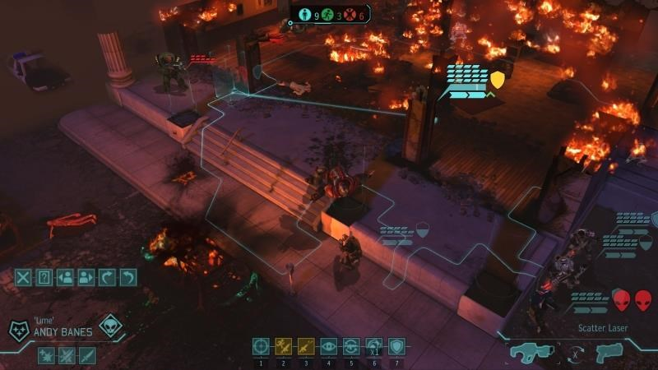

Shadowrun Returns
Shadowrun Returns is a tactical role-playing game for PC/Android. The player is able to customize their character's gender and appearance. Combat is turn based, with the player controlling the actions of their team followed by the enemies taking their actions.
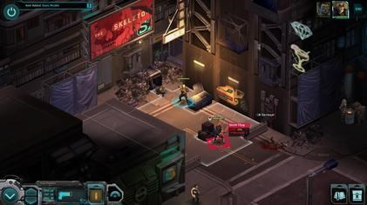

Dragon Age: Inquisition
Dragon Age: Inquisition, the third part of a series is a fantasy role-playing games. It’s about elves, demons and dragons in a collection of worlds. Players can choose between male or female and play as a human, dwarf, or elf. Combat focuses more on a player's ability to prepare, position, and form a cohesive team with his or her party members. Note this game has mature content.
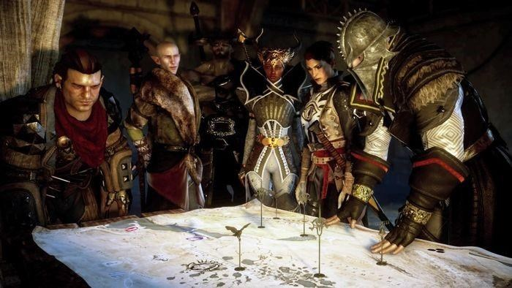

Accessible games online resources
- Games accessibility project focuses on the accessibility of electronic games for gamers with disabilities. This website aims to inform disabled gamers about the availability of accessible games http://www.gamehttp://www.game-accessibility.com/accessibility.com/
- Robert Florio is a quadriplegic gamer/developer, currently working on making a universal accessible game. http://www.robertflorio.com/gamehttp://www.robertflorio.com/game-accessibilityaccessibility
- Ablegamers.com is a website that looks to bring mainstream games to the disabled community. http://www.unstoppablegamer.com/
- Oneswitch.org.uk has a large resource on accessible gaming and accessible game consoles.
- Special Effect GameBase Centralised place for people to review good and bad games.
- Acid-Play.com - Around 25 one-switch game reviews.
- Game-Accessibility.com - One-switch forums for games old and new.
- RetroRemakes - News from the pioneering RetroRemakes community.
- Audiogames, as opposed to video games are computer games whose main output is sound rather than graphics. Using sound, games can have dimensions of atmosphere, and possibilities for gameplay that don't exist with visuals alone, as well as providing games far more accessible to people with all levels of sight. E.g. http://gamehttp://game-accessibility.com/game/audio-gamehub/accessibility.com/game/audio-gamehub/

Other useful game review sites

- Deaf Gamers - A superb games review, but inactive at the time of writing.
- Easy Allies - Video clips of console and PC games.

Game Consoles (Xbox and Wii)
The accessibility of game consoles such as the Xbox 360, Kinect, Wii are largely dependent on the games played. Alternative controllers may greatly improve the accessibility of a game. Options such as switch access or larger joysticks are available

Accessible game controllers

Six Switch Controller
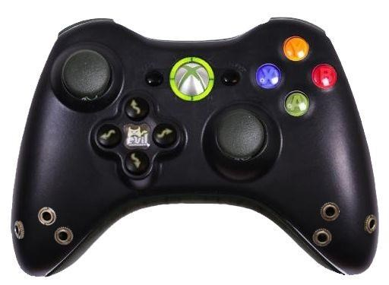
This six-button, fully switch enabled, and programmable controller for the Xbox 360. With six 3.5 mm jacks that allow you to add a switch to replicate the function of the buttons on the controller. All of these 6 ports are programmable, which means you can make any of the 6 ports function as any button on the controller. Cost $200 http://www.evilcontrollers.com/6-switch-mod-708.html

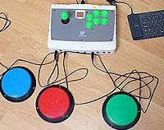
Switch Interface Deluxe

A versatile adapted arcade stick controller that can accept from one to 27 external accessibility switches. Compatible with PC, PS2, PS3 and Xbox 360.
https://youtu.be/6pvegeFITxM

XIM EDGE
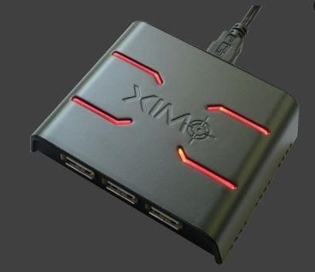
XIM4 provides the mouse and keyboard (and more) experience on Xbox One, PlayStation 4, Xbox 360, and PlayStation 3. XIM4 enables gamers to choose their preferred input devices that suit them best http://store.xim3.com/ https://youtu.be/q11rnJUleuI

Quad Button Box w/Xbox 360 or PS3 Game Controller
https://store.rjcooper.com/products/quad-button-box-for-game-controller
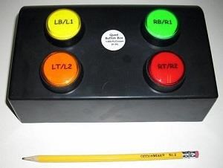
Other controllers http://www.oneswitch.org.uk/1/AGS.htm
Review of console games
http://www.unstoppablegamer.com/category/accessible-game-reviews/

Switch adapted toys

There are a number of suppliers of “Off the shelf toys” that have been adapted for switch use. This type of adaptation is suitable for simple operated toys as seen in the samples below.
Suppliers
- Inclusive technology http://www.inclusive.co.uk/hardware/switchhttp://www.inclusive.co.uk/hardware/switch-adapted-toysadapted-toys
- One switch.org http://www.oneswitch.org.uk/1shop.htm
- Liberator https://www.liberator.co.uk/products/learning-andhttps://www.liberator.co.uk/products/learning-and-inclusion-aids/switch-adapted-toysinclusion-aids/switch-adapted-toys
- Ability-World http://www.ability-world.com/switch-adapted-toys-controllers-44-c.asp

Sample of Toys

Switch Adapted Toy - Talking Toy Story Sheriff Woody
Connect any 3.5mm switch to make Woody talk.
Each switch press will make him say a different phrase: “You’re my favourite deputy”, “reach for the sky” and “there’s a snake in my boots” are just three of Talking Woody’s fifty sayings taken from the popular Toy Story films.
£88.74
http://www.ability-world.com/switch-adapted-toy-sheriff-woodyhttp://www.ability-world.com/switch-adapted-toy-sheriff-woody-interactive-toy-7395-vat-1741-p.aspinteractive-toy-7395-vat-1741-p.asp

Switch Adapted Toy - Penguin Racer
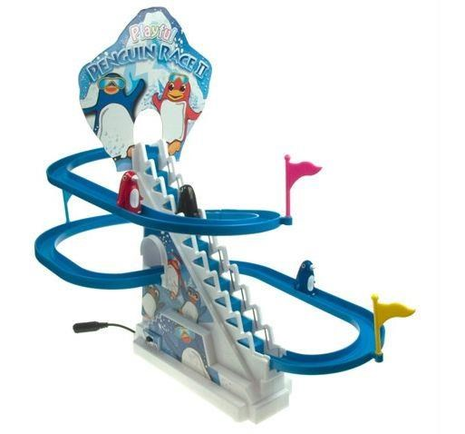
Penguin Racer is a switch adapted toy encouraging learners to press a switch and set the three penguins off on a race!
Watch as the penguins are hoisted up the ski lift ladder, then slide quickly down the winding slope before they do it all over again. Height is approximately 14"/36cm. Contains small parts.
Use a 3.5mm switch
£34.00 http://www.inclusive.co.uk/switch-adapted-toy-penguin-racer-p5781

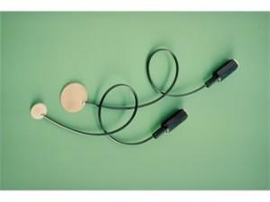
Modification of toys

Battery Switch Adaptors
Some toys have a single on-off switch - you turn it on and it does something, you turn it off and it stops doing it. These toys are easily modified with a small device called a power interrupter (battery switch adaptor) that slips in between two of the batteries in the battery holder. £9 http://www.inclusive.co.uk/battery-switch-adaptors-p2541 http://www.youtube.com/watch?v=DaivAvvvKy0

Toy switch adaptation of battery operated toys
There are some useful videos online that demonstrate how battery operated toys can be made switch accessible. It is necessary to find the single on-off switch - you turn it on and it does something, you turn it off and it stops doing it. You then modify this with a switch socket.

For example see the following video for an example of adaptation of a toy.
http://www.youtube.com/watch?v=nxNtdBfaoW8

Visual toys

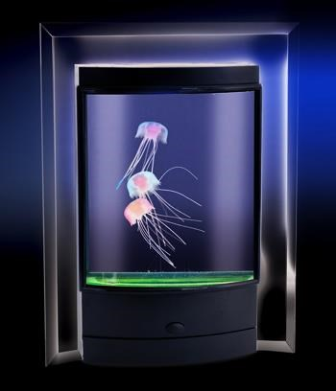
Magic Jellyfish
Multicolored LED lighting provides an illumination of Jellyfish that bob up and down in the mini-aquarium.
Dimensions (L x W x H): 60 x 185 x 250 mm

http://www.maplin.co.uk/p/magic-jellyfish-n98kf
http://www.youtube.com/watch?v=h7TxIc65-5c

Plasma Ball
This light patterns inside the globe will respond to your touch or can be left to run alone or set to dance to the beat of music. It is mains operated. €27.99
http://goo.gl/kPJOeO http://www.youtube.com/watch?v=DB72OUh8f5Y

Swirl Ball - 10cm diameter
Clear bouncy ball that has small colorful beads inside that move when rolled or bounced.

http://www.specialneedstoys.com/uk/sensory/sensory-balls/swirlhttp://www.specialneedstoys.com/uk/sensory/sensory-balls/swirl-ball-visual-sensory-toy.htmlball-visual-sensory-toy.html

Rainbow Shakers
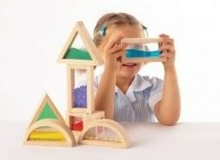
16 hardwood envelopes contain 3 different materials: Sand; Beads; and Glitter.
• Dimensions: 15 x 8 x 4

£37.25 http://www.specialneedstoys.com/uk/visual/colours/rainbow-shakers-visual-sensroyhttp://www.specialneedstoys.com/uk/visual/colours/rainbow-shakers-visual-sensroy-toy.htmltoy.html

Rainbow Letters
26 acrylic letters in bright clear colours and a clear font.
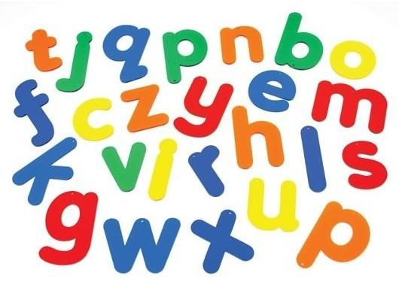
• Dimensions: 7cm

£14.99 http://www.specialneedstoys.com/uk/visual/colours/rainbow-letters-visual-sensoryhttp://www.specialneedstoys.com/uk/visual/colours/rainbow-letters-visual-sensory-toy.htmltoy.html

Boing Pro
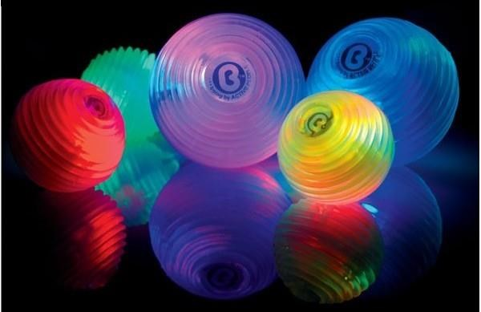
Rubbery light-filled ball, every time it's squeezed it changes colour.
- Power: 2 x AA.
- Dimensions: 8cm dia
£7.95 tax excl.
https://www.amazon.co.uk/Special-Needs-Toys-Boinghttps://www.amazon.co.uk/Special-Needs-Toys-Boing-Pro/dp/B0018SBOM6Pro/dp/B0018SBOM6 https://youtu.be/LU7E9fzDJjo

Fantastik
You can stop this mesmeric fan with a finger without fear.
• Power: 2 x AA
£3.99

http://www.specialneedstoys.com/uk/visual/fantastik-visual-sensory-toy.html
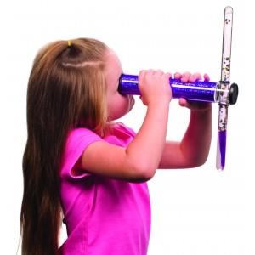

Kaleidoscope

This jumbo-sized kaleidoscope comes with a double-color glitter wand. Both of the colors create fun "slow-motion" images. Color of the Kaleidoscope varies.
• Dimensions: 9
£11.95
http://www.specialneedstoys.com/uk/visual/eye-candy/kaleidoscope-visual-sensoryhttp://www.specialneedstoys.com/uk/visual/eye-candy/kaleidoscope-visual-sensory-toy.htmltoy.html

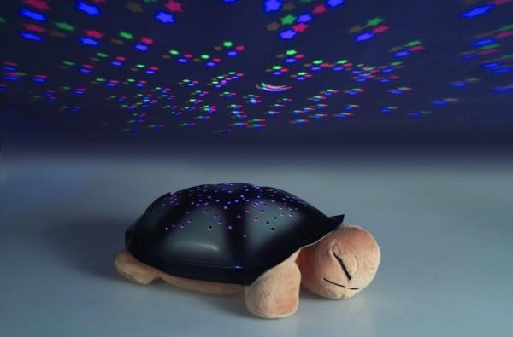
Star Turtle
Stars shine from this sleeping reptile's shell
- Power: 3 x AAA
- Dimensions: 30 x 20 x 11cm
£26.25

http://www.specialneedstoys.com/uk/visual/star-turtle-visual-sensory-toy.html

SandScapes
Slow moving sand sculptures. Flip it over to reset. Dimensions: 20 x 14cm,£14.50
http://www.officeplayground.com/office-decor-c888/sandhttp://www.officeplayground.com/office-decor-c888/sand-pictures-c200.htmlpictures-c200.html

Auditory

World Playground
Playground CD's & DVD's with upbeat sounds for playtime and dancing. £12.95 https://www.amazon.co.uk/World-Playground-Putumayo-Kids-
Presents/dp/B00000JT4P/ref=sr_1_1?ie=UTF8&qid=1481129977&sr=8-
1&keywords=world+playground+cd

African Dreamland
Dreamland CD's & DVD's blend soft and melodic tunes to help sooths and relax children when it is time to unwind.
£12.95
https://goo.gl/y3hV8v

Celtic Dreamland
Playground CD's & DVD's with upbeat sounds for playtime and dancing.
£12.95

https://goo.gl/kOny1W

Ball, Audible Mitre football

Inflatable white rubber football, fitted with carbon steel balls (ball bearings) which rattle when the football is shaken or moved. Encourages physical play, listening skills and development of spatial awareness. Size five ball. Suggested age range: 3 years plus Diameter:21.5cm (8.46") https://www.ncbi.ie/product/ball-dl108433/ See other auditory toys http://www.specialneedstoys.com/uk/auditory/ http://www.rehabmart.com/category/pediatric_auditory_stimulation.htm

Tactile toys

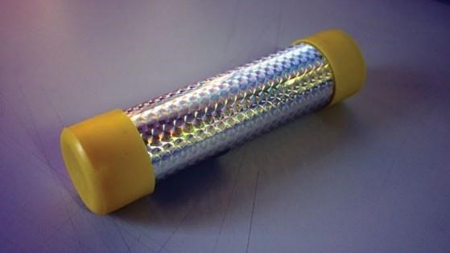
Texture Tangle

Bumpy, rough and squidgy version of the popular Tangle. £17.95
http://www.specialneedstoys.com/uk/tactile/476-texture-tangle.html

Vibro Tube

Indestructible wipe-clean proprioceptive aid that vibrates. Off when horizontal, twist it in the air to turn it on.
- Power: 2 x AA.
- Dimensions: 18cm
£55.00
http://www.specialneedstoys.com/uk/proprioception/vibro-tube-sensory-tactilehttp://www.specialneedstoys.com/uk/proprioception/vibro-tube-sensory-tactile-toy.htmltoy.html

TherapyTangle
Rubbery version of the popular manipulative that gives your hands a mind of their own. Latex-free.
NOT SUITABLE FOR PERSONS UNDER 6 YEARS
£9.50
http://www.specialneedstoys.com/uk/tactile/479http://www.specialneedstoys.com/uk/tactile/479-therapytangle.htmltherapytangle.html

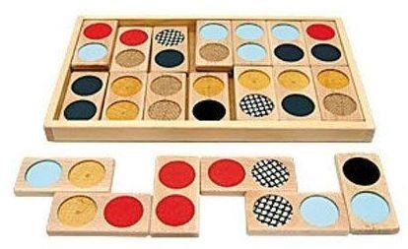
Dominoes - tactile
A tactile domino game of 28 wooden tiles with a combination of 7 different textures. From 3 years
€25.40
https://goo.gl/xWNPcG

DominObjects

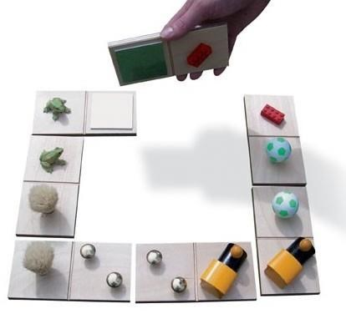
Firmly fixed to the wooden tiles are a magnificent selection of things that can be matched with their mate. Single set of
7.
• Dimensions: 8 x 15cm
£49.00
https://www.amazon.co.uk/s/ref=nb_sb_noss?url=searchhttps://www.amazon.co.uk/s/ref=nb_sb_noss?url=search-alias%3Daps&field-keywords=DominObjectsalias%3Daps&field-keywords=DominObjects

Ball Tactile
This brainteaser provides challenging fun for everyone who enjoys using both their mind and their hands together to solve a puzzle. It's also accessible to the Blind. Take the pieces apart and reassemble them into the original soccer ball shape. Made of smooth-sanded wood with a brown stained finish. Approx. diameter: 3 inches. Weight: 4.2 oz.
€9.00
https://blindfoundation.org.nz/how-we-can-help/shop/around-the-home/recreationhttps://blindfoundation.org.nz/how-we-can-help/shop/around-the-home/recreation-games/tactile-wooden-ball-puzzle/games/tactile-wooden-ball-puzzle/
http://www.specialneedstoys.com/uk/tactile/soft-toys/tactile-balls-sensory-fingerhttp://www.specialneedstoys.com/uk/tactile/soft-toys/tactile-balls-sensory-finger-toy.htmltoy.html

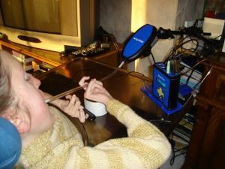
Musical toys and instruments

Magic Flute
The Magic Flute is an electronic musical instrument that enables people whose only reliable movement is the head and breath to play music. The flute is similar to a harmonica or slide whistle in that it requires no fingers to play and both note and expression can be controlled using the mouth.
https://youtu.be/VY9Zx2fMhLs http://housemate.ie/magic-flute/

Quintet
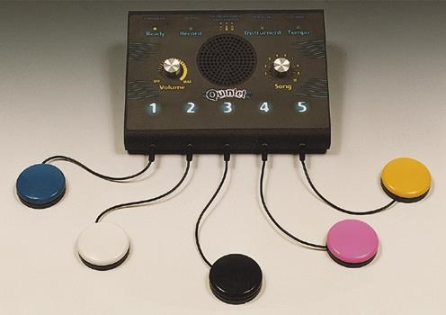
The Quintet is for teachers, therapists, parents and others who want to use music in an activity with children or adults. It can be used with a group of people or by a single individual. Because you do not need to be an expert in music to operate the Quintet it can be used in many situations including Classroom activities, Music Therapy workshops, Occupational Therapy sessions and much more. http://housemate.ie/quintet/

Skoog 2
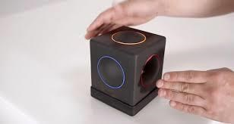
A tactile to create and learn music. Skoog is a powerful and fun music interface for iPad that opens up a world of ‘music play’ to everyone, including those with disabilities.
http://skoogmusic.com/
https://www.youtube.com/watch?v=IDGREk0YuSA

Hands-On 10-piece Percussion Set

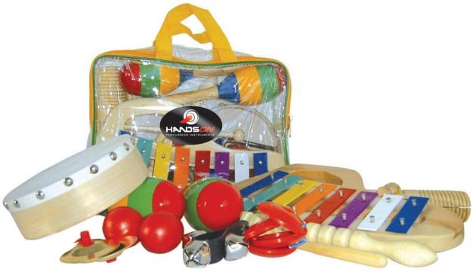
Hands-On 10-piece Percussion Set includes a pair of maracas, a metallophone, castanets, finger cymbals, wrist bells, two egg shakers, wood-block, hand-drum, wood agogo € 48.00
http://www.waltons.ie/home/products/view/09ahanhttp://www.waltons.ie/home/products/view/09ahan-lt10a-hands-on-percussion-set-10-piece/lt10a-hands-on-percussion-set-10-piece/

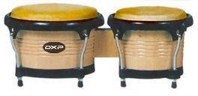
DXP Bongo Set
€ 69.00
http://www.waltons.ie/home/products/view/09adxp-jdbhttp://www.waltons.ie/home/products/view/09adxp-jdb-101-dxp-jdb-101-bongos-natural/101-dxp-jdb-101-bongos-natural/

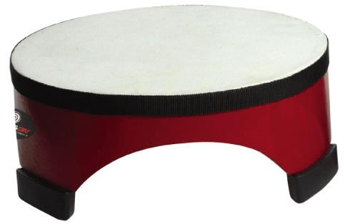
Hands-on Floor Drum 20x9cm
€ 12.00
http://www.waltons.ie/home/products/view/09ahan-lyhd-10ahttp://www.waltons.ie/home/products/view/09ahan-lyhd-10a-hands-on-20-x-9-cm-floor-drum-red/hands-on-20-x-9-cm-floor-drum-red/

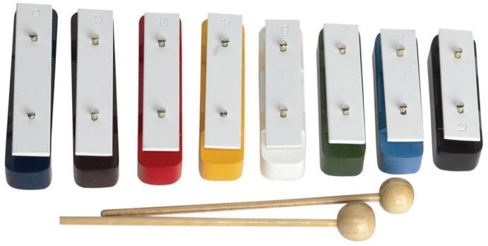

Hands-on Metallophone
€ 13.00 http://www.waltons.ie/Product/View.aspx?id=28189&cid=240

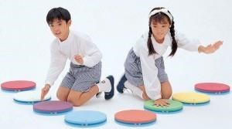
Footnotes
8 rugged notes that can be spread around, jump on them to play them.
£351.00

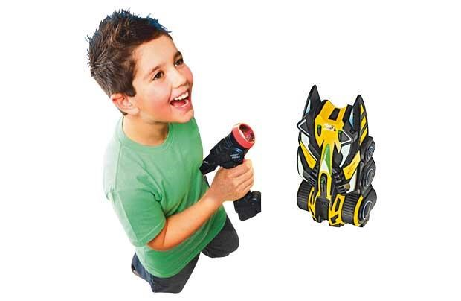
http://www.specialneedstoys.com/uk/motor/footnotes-noisy-sensory-toy.html

Electronic Toys

Air Hogs Remote Controlled Laser Zero Gravity Vehicle

Just point the light beam and watch the vehicle chase it up the wall or upside down.
- Only works on smooth surfaces.
- For ages 8 years and over. https://goo.gl/pDo8fW https://youtu.be/UPw4qYG7Tsw

Thomas V.Smile Motion Active Learning System

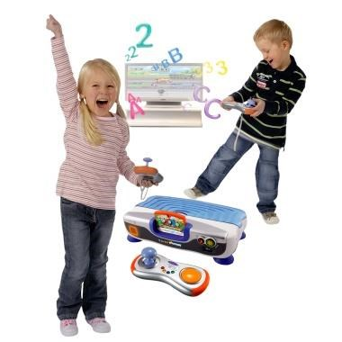
Pre-school TV learning console, complete with motion sensing wireless controller. Accompanied by Thomas & Friends Learning Game introducing colours, shapes, vocabulary, numbers, logic, spelling and more. Add a second joystick (not included) for 2-player gaming. TV, extra controller and mains adaptor not included.
€34.99 https://goo.gl/KqBDB9

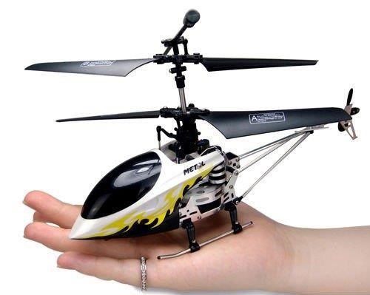
4 Channel Indoor I/R Helicopter

Infrared helicopter with built in gyroscope that automatically balances the helicopter in flight. Maneuverability options include forward/backward, up/down, left rotate/ right rotate, left bank/right bank.
http://www.maplin.co.uk/p/4-channel-indoor-ir-helicopterhttp://www.maplin.co.uk/p/4-channel-indoor-ir-helicopter-n14jwn14jw http://www.youtube.com/watch?v=JnQTdTh-Bns
€30

Roborover
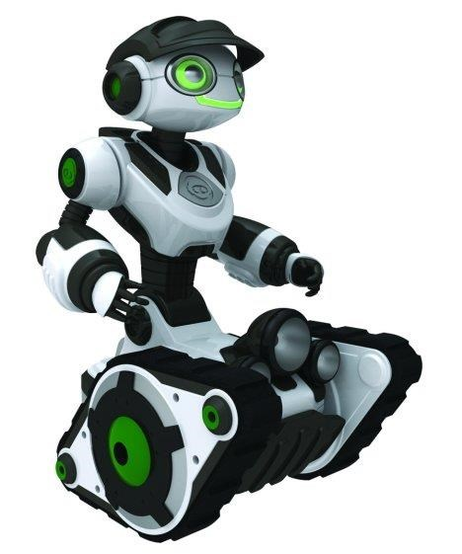
WowWee’s Roborover is part of its Robotics line, and is operated through a remote control. This talking robot comes with some spoken content and a bunch of driving-based games.
These toys can be made more accessible by controlling them through the computer with UIRT as detailed below.
http://www.wowwee.com/en/products/toys/robots/robotics https://youtu.be/JOSLmCGh8Kg

Robotic Arm Kit with USB PC Interface

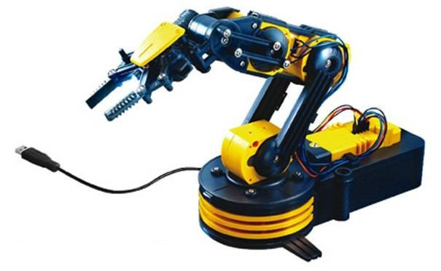
This robotic arm can be controlled via your PC via USB port. Includes software for controlling the arm that enables your keyboard and mouse to have real time control. Programming option to save or load preprogrammed user files for a series of movements. Maximum Lift 100g.
http://www.maplin.co.uk/p/robotic-arm-kit-with-usbhttp://www.maplin.co.uk/p/robotic-arm-kit-with-usb-pc-interface-a37jnpc-interface-a37jn https://youtu.be/0w-tN_E4lEo

Universal Infrared Receiver Transmitter

UIRT
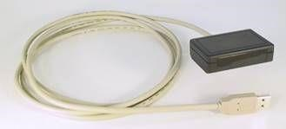
This is a device that could be used to interface to many toys or games that are controlled by infrared. The UIRT is a Universal Infrared Receiver Transmitter. It is typically used along with Automation Software however used with GRID 3 from thinksmartbox you can create custom onscreen layouts to control your infrared devices. You start by learning the remote controls from remote controlled toy. This can then be reproduced from the computer when selected allowing you to control games or toy. You can use the assistive technology that is installed on the PC to access your device.
UIRT $50 Grid €500 http://www.usbuirt.com/

Tira
Similar to the above http://www.home-electro.com/products/tira-21

Traditional Games
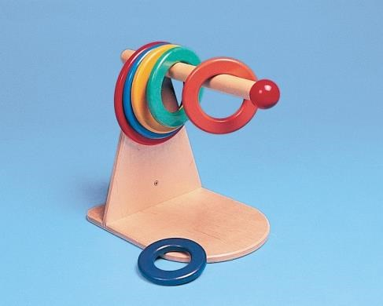

Wooden rings and stand
Can be used vertically or horizontally. Includes 6 rings graded in size €89.00

http://www.thinkingtoys.ie/gross-motor-skills--all?product_id=2271

Pallina
A dexterity game for 2-6 players aged 4 and upwards. The sticks have to be pulled out of the tower without letting a nugget falling down - this is a big challenge for fine motor skills. £18.00
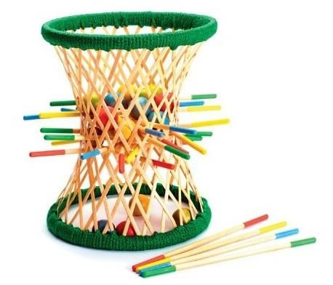

https://www.amazon.com/Pallina-Bamboo-Sticks-Ballshttps://www.amazon.com/Pallina-Bamboo-Sticks-Balls-Game/dp/B0042RVNFIGame/dp/B0042RVNFI

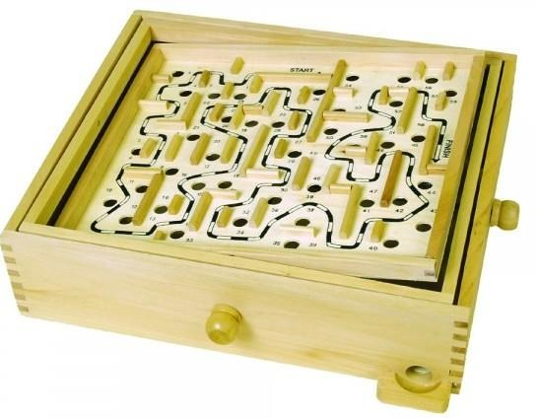

Wood Labyrinth
Turn the two knobs to maneuver the steel ball through the maze of holes.
• Dimensions: 13" x 11" x 3.5"
£21.95 https://goo.gl/CX6NvC

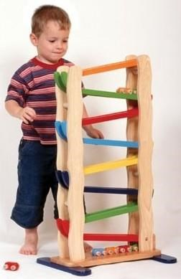
Tower Slope
Rise to place a vehicle at the top of the slope and it slides and flips its way elegantly down again.
• Dimensions: 28 x 46 x 79cm
£67.25
http://www.specialneedstoys.com/uk/fine-motor/1133-towerhttp://www.specialneedstoys.com/uk/fine-motor/1133-tower-slope.htmlslope.html

Cards, Giant sized playing cards
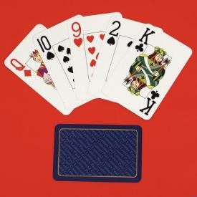
Larger than an average pack of playing cards printed with giant easy-tosee letters and numbers. Cards measure 8.9cm (3.5 inches) by 13.6cm (5.25 inches). Characters measure 2.5cm (0.6 inches) in height. The diamond, club, spade and heart are also much larger and are easily identifiable.
Width:8.9cm (3.5") Length:13.6cm (5.35")
€4.00 http://www.ncbi.ie/product/cards-giant-sized-playing-cards-gc09/

Irish businesses
There are many Irish businesses who cater for parents, grandparents etc, who will be searching for something fun for children with extra needs. Some companies are specialised, focusing entirely on children with extra needs, while for others it may be just a small part of their business. Either way, there are, hopefully, sufficient businesses out there offering a big enough range to satisfy all children.

Sensational Kids
A non-profit provider of affordable and accessible early intervention services for children with additional needs.
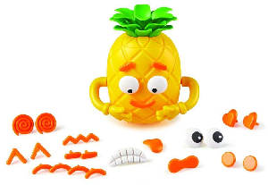

Big Feelings Pineapple.
The charity – which has a child development centre in each province: Kildare Town; Claremorris, Co Mayo; Clones, Co Monaghan; and Clonakilty, Co Cork – offers many gifts for children with extra needs.
Munchy Play
Munchy Play is based on a very simple idea. The plates feature a built-in track for toy trains and cars, which makes mealtimes more fun for the child and, hopefully, less stressful for the parent.

Aoibheann’s Pink Tie
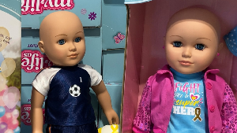
Aoibheann's Pink Tie will help and offer practical support to the families of children diagnosed with cancer and who are attending St John's Oncology Ward in Our Lady's Children's Hospital.. Bald dolls to the childrento help them understand what they are going through because of chemo.

Jiminy Eco Toys
The site has hundreds of toys and books, including a large number of “Sensory toys”. The collection – all made in Europe and plastic-free to align with the company’s eco mission – includes giant bubbles, wooden puzzles and slime.

Pikodo
While this Kildare-based company with toys mostly for toddlers and young children.
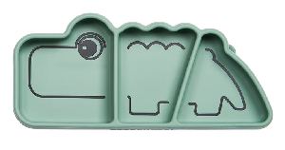

Discovery Playtime
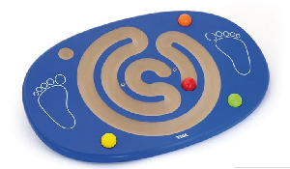
Mireia Lopez founded Discovery Playtime in 2017 and the online store offers a big selection of educational, sensory and wooden toys

Sully & Juno
Sully & Juno – which offers colourful jumpers, leggings, T-shirts and more

Cool Food School
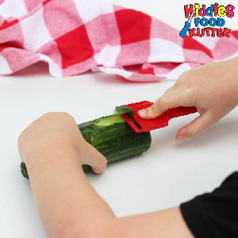
In the online shop, Deirdre Doyle offers safe knives and peelers, which gives children more independence while they make those buns that you’re just going to have to eat, no matter how they look.

Little AngelRose
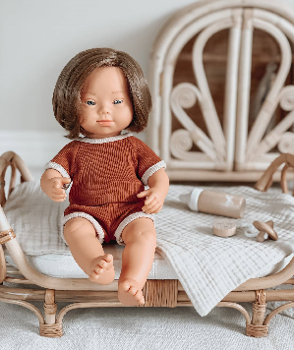
The small Irish company specialises in rattan toys and furniture for dolls, and boho nursery decor, and it promises that the collection is ethically made.

Cog the Brain Shop
As the name suggests, the store sells smart and unique toys, puzzles, games and books for all ages
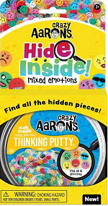

Thinking Toys
Thinking Toys has many toys in categories “Suspension”, “Motor Skills”, “Communication”, and “Sitting Aids”.

Useful links

Sites for educational toys and special needs products

- http://www.specialneedstoys.com/uk/
- http://www.thinkingtoys.ie/
- http://adamandfriends.ie/estore/
- https://www.ncbi.ie/product-category/games/

General Assistive Technology suppliers

EdTech Software Ltd
Mayo Phone: + (353) 098 64886 and LoCall 1850 923 459 http://www.edtech.ie/

Inclusive Technology Ltd
United Kingdom Phone: + (44) 01457 819790 http://www.inclusive.co.uk

Jackson Technology
Dublin Phone: + (353) 01 451 8508 http://www.jacksontechnology.com/

Unique Perspective
Designs and develops accessible devices such as musical instruments, environmental control devices, switch accessible phone etc.
http://housemate.ie/

Help Kids Learn
is a site of accessible software games geared towards young children.
http://www.helpkidzlearn.com/

RJ Cooper
has information on various switch adapted devices and iPad accessories http://www.rjcooper.com/

Appendix

iPad Apps

Cause and Effect/Simple games
- Balloons
- Pop Balloons
- Bubble Wrap
- Bubble Snap
- I love Fireworks
- Draw Stars
- BubbleXplode
- Touch Music
- iFish Pond
- Animals Lite
- Stop & Go
- Talking Ben/Tom/Santa/rex etc.
- Peekaboo Ocean
- Peekaboo barn
- Furry friend
- Fart Piano
- Burp and Fart Piano
- Rattle
- Garbage truck
- Old MacDonald

Reading
- Hairy Maclary
- Bartleby
- Cat in the Hat
- Create your own stories o StoryBuddy o Pictello o My Story o Tellastory
o Pictello

Music
- Virtuoso
- Baby touch Music
- Piano School
- TonePad
- String Trio
- Songify
- Inception Xylo

Fine motor Games
- Mosaic
- Solitaire
- DangerFinger
- Fast Finger
- FingerPaint
- Clouds
- TouchTrainer
- Paint and Learn
- AMaze Friends
- Kids Puzzle
- Pop Lite
- DTDNumLetLite
- Puzzle
- Save the Fishes
- Puzzles ‘N Coloring
- Air Hockey
- Skill game

Art
- Doodle Buddy
- iColoring
- Colors
- Coloring
- Colours
- Free Paint
- PaintSparkles
- Kids Drawings
- Kiddy Art
- Sketch Club
- Puzzles ‘N Coloring
- We doodle

Visual Discrimination
- Find Me!
- Match It Up
- 10 Pin shuffle
- Amazing Shape Puzzle

Fun strategy games
- Checkers
- Sudoku
- AngryBirds
- BlockSAhooter
- Fragger

Switch Games
- Catch the cow
- A leader is
- Adapted Play Book – EIEIO/Peanut Butter
- Bumper cars
- Aunty Maggie’s Recipes/Smarty pants/Five Little Aliens/Five Sharks
Swimming – Inclusive technology
- Rad sounds
- Scan and Match
- I Can help
- KoppyKatz
- Hurdle Champion
- Space Shooter
- SwitchKids
- Train Tracker

NB! Remember to check which switch box is suitable for the chosen app – useful list http://www.janefarrall.com/html/resources/Switch%20Accessible%20Apps%20for%20iPad.pdf

